CASH

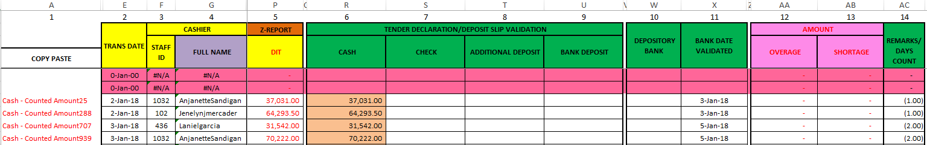

BPI-E, BDO-E

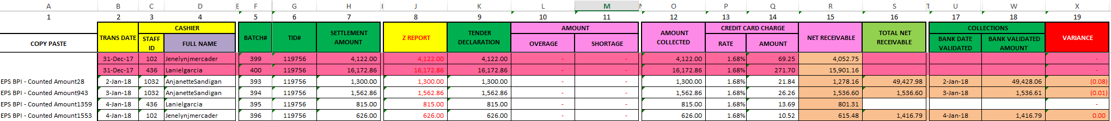

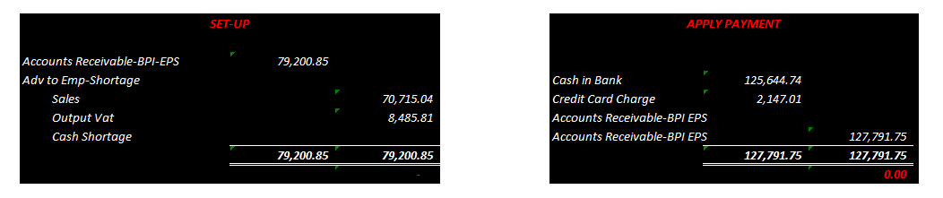

BPI, BDO, DINERS, MB, OP, AR CORP



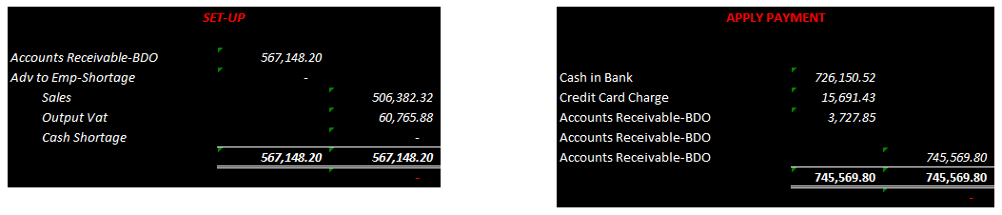

|  |  |
| --- | --- |
| *for encoding* | *with V look-up* |
| *from POS back office* | *with formula/link* |

